4. AWS vs. GCP vs. Azure

The main cloud service providers are:

1. Amazon web Services.
2. Google Cloud Platform.
3. Microsoft Azure.

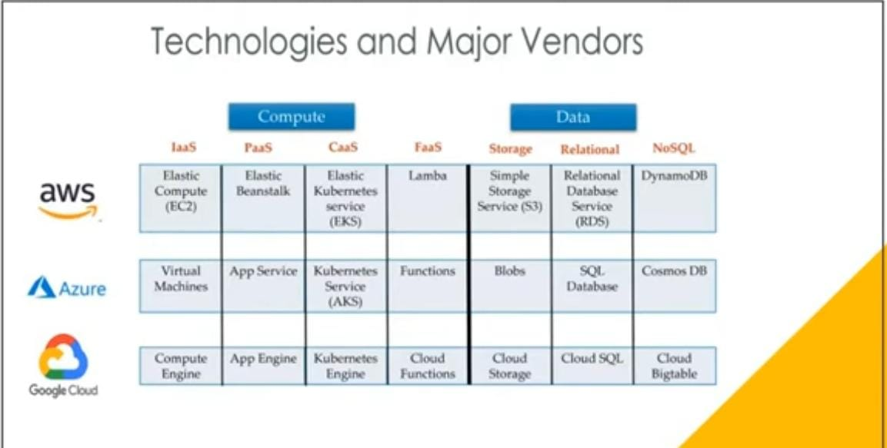

AWS:

Compute:

* Infrastructure as a Service – Elastic Cloud Compute (EC2).
* Platform as a Service – Elastic Beanstalk.
* Code as a service – Elastic Kubernetes Service (EKS).
* FAAS – Lambda.

Data:

* Storage: Simple Storage Service (S3).
* Relational: Relational database Service (RDS).
* NoSQL: Dynamo DB.